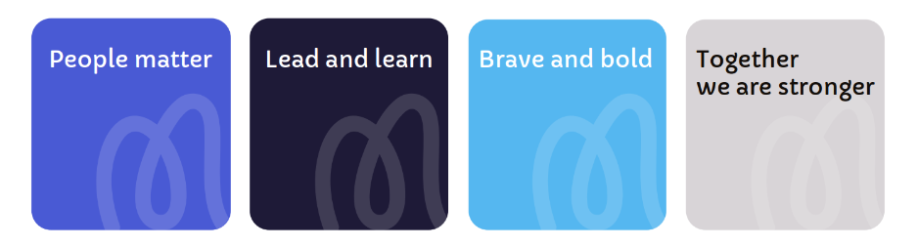
Job Title: Receptionist
Salary: £8,807.45
Location: Little Hulton
Responsible to: Estates Manager
Core Purpose: Providing a welcoming and compassionate reception service, offering administrative support to ensure the smooth and professional operation of the hospice.

Core Purpose: <Text Here>
Job Role Profile
At Moya Cole Hospice, there’s one thing that motivates us and that’s
providing excellent care and support to those living with or affected by life-limiting illnesses.
We’re continuously developing our plans for delivering world-class, innovative care to ensure Moya Cole Hospice is in the best shape possible for future generations.
You’ll be challenged, inspired and empowered to help us achieve our purpose and to play your part in making a difference,

We’re proud to care
We’re proud to work together
We’re proud to make a difference

Head of Facilities
Team Organisational Chart

Estates Manager

Receptionist

Job Summary
- Provide a courteous, professional and caring first impression of St Ann’s Hospice.
- Meet and greet patients and visitors into the hospice and deal with enquiries in an efficient, polite and courteous manner providing a caring, considerate service to everyone.
- Answer telephone queries and take messages where appropriate, transfer calls and direct visitors to the correct location.
Responsibilities
The Receptionist will:
- Provide a professional first impression of the hospice
- Work closely with the nursing team announcing patient arrivals
- Communicate with all departments regarding visitor arrivals
- Safeguard patient and visitor confidentiality at all times including adherence to Data Protect Act following GDPR
- Provide information on services and retail products.
Requirements
The Receptionist will:
- Be committed to developing IT and digital skills
- Have experience of working in a customer service role
- Have experience of working in a reception role in a similar environment would be desirable
- Have a general level of education to GCSE or equivalent.

The Receptionist will be able to:
- Appropriately escalate where necessary to the relevant staff members
- Ensure our values are following at all times
- Ensure all access/entry guidelines are followed by visitors
- Assist in an emergency situation following directions from the Nurse in Charge
- Answer phone calls and deal with enquiries
- Adapt your approach and communication techniques to meet patient’s specific needs
- Liaise with contractors ensuring the correct documentation is completed before they start work.
Skills, Qualifications and Experience
- Have excellent communication and interpersonal skills, with a compassionate and professional manner
- Demonstrate strong organisational and administrative abilities, with excellent attention to detail
- Be competent in the use of Microsoft Office and general office systems
- Have previous experience in a reception or administrative role, ideally within a healthcare setting (desirable)
- Be able to handle sensitive and confidential information appropriately
- Have a calm and empathetic approach when dealing with patients, families, and visitors
- Be flexible and team-oriented, with a willingness to support wider hospice activities.

Terms and Conditions for Receptionist
Contract Permanent
Work Pattern 13.5 hours over 3 days per week
4.5 Hours per day, Mon, Tue and Fri 12:30 to 17:00
Location Little Hulton
Free Parking Free parking at our Heald Green and Little Hulton sites
Holiday 35 days, increasing to 37 days after 5 years’ service and 41 days after 10 years’ service (pro rata, inclusive of bank holidays).
Pension Contributory Stakeholder pension in which we match up to 7% of your gross salary. Or the ability to continue with a previously held NHS pension (subject to making contributions into the scheme in the previous 12 months).
Life Cover All staff in the Scottish Widows Pension scheme (with the exception of bank staff) are provided with life cover of three times their basic salary in the event of their death whilst employed by Moya Cole Hospice.
Health Cash Plan We offer access to an employee paid health cash plan. That allows employees to spread the cost of health expenses including dental, optical, physiotherapy and more.
Employee Assistance Programme Employees can access telephone and online counselling 24 hours a day. Face to face counselling is also available and support on issues including debt, employment law, benefits and housing.
Probation Six months
Notice 4 weeks
Safeguarding Any post holder within the organisation will be expected to undertake safeguarding training appropriate to their role and adhere to safeguarding policies and procedures. All staff must work in accordance with their statutory roles and responsibilities in relation to safeguarding in accordance with the Working Together to Safeguarding Children 2023, The Care Act 2014, and Prevent Duty 2015.

