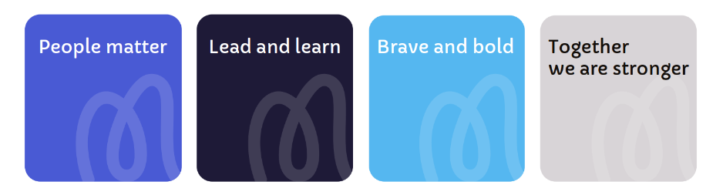
Job Title: Healthcare Assistant
Salary: Hospice Band 3, Competency Based Framework, £24,937 - £26,598 per annum (pro rata).

Location: Little Hulton
Responsible to: Ward Manager
Core Purpose: To assist with the provision of specialist palliative care.

Job Role Profile
At Moya Cole Hospice, there’s one thing that motivates us and that’s
providing excellent care and support to those living with or affected by life-limiting illnesses.
We’re continuously developing our plans for delivering world-class, innovative care to ensure Moya Cole Hospice is in the best shape possible for future generations.
You’ll be challenged, inspired and empowered to help us achieve our purpose and to play your part in making a difference,

We’re proud to care
We’re proud to work together
We’re proud to make a difference

Deputy Head of Clinical Services
Team Organisational Chart

Ward Manager

Staff Nurse
Healthcare assistant

Job Summary
To work as a Health Care Assistant (HCA) within the inpatient unit, supporting patients (and those close to them) with a life limiting illness. Working within the policy framework of the hospice to help ensure the organisational aims are met.

The HCA will work closely with the registered nurses to support the assessment, planning, evaluation and delivery of all relevant aspects of specialist palliative patient care in a compassionate and sensitive manner.

The HCA is an integral part of the multi-disciplinary team and the HCA will foster good working relationships with other team members to ensure the delivery of high quality, safe and timely support to patients and those close to them.

Moya Cole delivers a service across two sites. Whilst you will have a specific base, there may be occasions where you are required to provide cross-site / service cover.

Responsibilities
The Healthcare Assistant will:
- Provide holistic palliative care and support (appropriate to their role as a HCA) to patients and those closest to them
- Ensure accurate record keeping on EMIS in accordance with organisational requirements
- Effectively communicate with members of the multidisciplinary team and contribute to the planning of care
- Work in accordance with hospice policies to ensure that confidentiality is maintained at all times.
- Assist in providing bereavement support to carers and relative, participating in relevant remembrance events.
- Actively participate in the hospice Performance Development review process to identify own learning needs and take necessary steps to reach objectives and develop own competence to practice.
- Use support systems appropriately to support wellbeing and personal development e.g. Schwartz rounds, reflection sessions.
- Act as an ambassador for Moya Cole Hospice by maintaining a professional attitude and appearance at all times.
- Provide support to new members of the team, students and volunteers.
- Support the team in developing and implementing agreed team initiatives.
- Take an active part in ward meetings.
- Support with relevant link groups.
Skills, Qualifications and Experience
The Healthcare Assistant will be able to:
- Demonstrate the Right to Work in the UK without requiring sponsorship
- Demonstrate an interest in specialist palliative care
- Be willing to work towards a Care Certificate
- Have undertaken training in, or demonstrate experience in communication skills
- Demonstrate previous experience of working as a HCA in hospital or other similar care setting.
- Be committed to developing your IT and digital skills
- Use their own initiative and help prioritise day-to-day work.
- Communicate effectively in verbal and written form.
- Work as a team player
- Maintain strict confidentiality
- Demonstrate an understanding of safeguarding and the importance of promoting the welfare of adults and children.
- Display a positive, kind, empathetic and person-centred approach.
- Demonstrate knowledge of clinical governance and personal responsibilities.
- Be flexible and willing to work day and night shifts/unsocial hours.

Terms and Conditions for Healthcare Assistant
Contract Permanent 23 hours/week
Work Pattern 23 hours per week, 11.5 hr shifts - including night shifts and weekend working on a rota basis. Enhancements of between 30% and 60% for weekend, bank holidays, unsocial hours
Location Little Hulton
Free Parking Free parking at our Heald Green and Little Hulton sites
Holiday 35 days, increasing to 37 days after 5 years’ service and 41 days after 10 years’ service (pro rata, inclusive of bank holidays). In addition, staff are able to buy up to 1 weeks’ holiday per year via salary sacrifice, pro rata.
Pension Contributory Stakeholder pension in which we match up to 7% of your gross salary. Or the ability to continue with a previously held NHS pension (subject to making contributions into the scheme in the previous 12 months).
Life Cover All staff in the Scottish Widows Pension scheme (with the exception of bank staff) are provided with life cover of three times their basic salary in the event of their death whilst employed by Moya Cole Hospice.
Health Cash Plan We offer access to an employee paid health cash plan. That allows employees to spread the cost of health expenses including dental, optical, physiotherapy and more.
Employee Assistance Programme Employees can access telephone and online counselling 24 hours a day. Face to face counselling is also available and support on issues including debt, employment law, benefits and housing.
Probation Six months
Notice Four weeks
Safeguarding Any post holder within the organisation will be expected to undertake safeguarding training appropriate to their role and adhere to safeguarding policies and procedures. All staff must work in accordance with their statutory roles and responsibilities in relation to safeguarding in accordance with the Working Together to Safeguarding Children 2023, The Care Act 2014, and Prevent Duty 2015.

