

Conductor John Pomphrey
Come and Sing with us for the day

Saturday 1st October 2022
Registration 9.00am with an informal performance at 3.45pm

Works by Lerner & Loewe, Lloyd Webber,
Cole Porter, Gilbert and Sullivan, John Rutter and Elgar

St Michael and All Angels Parish Church, Bramhall SK7 2PG
Ticket £20.00 Music provided on the day

To book a place:
Register by email and pay by bank transfer
OR Complete application form and post with cheque

Voices in all parts are welcome
Further details: www.hospicechoir.org Email: hospicechoir@aol.com 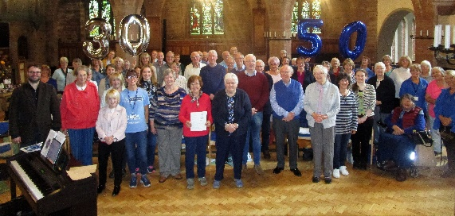
Raising funds for St Ann’s Hospice
Timetable
9.00am – 9.30am Registration, collect music
9.30am – 11.00am Workshop
11.00am –11.30pm Break for refreshments
11.30am - 1.00pm Workshop
1.00pm – 2.00pm Lunch break
2.00pm – 3.30pm Workshop
3.45pm – 4.15pm Performance for family/friends

Please bring food for lunch. Drinks and home-made cakes will be on sale during the morning and lunch breaks.

Music:
Will be provided on the day

Ticket:
Adult each £20
Students under 18 free
Payment is non-refundable if a place is allocated to you
A separate form is required for each application
By post:
Complete application form and send with cheque payable to St Ann’s Hospice Festival Choir
OR post application form and pay by bank transfer
Bank Account:
St Ann’s Hospice Festival Choir Ltd. Sort code: 20-82-13 a/c 63931994 Barclays Bank.
Please use your name as the reference.
Post completed forms to:
Mrs Carol Straffon, 11, Lingfield Avenue, Hazel Grove, STOCKPORT, Cheshire SK7 4SL.
Carol Straffon (Come and Sing Registration enquiries) 0161 612 1660

Apply by email:
Complete application form and email to straffon12@gmail.com
Pay by bank transfer to the account above.

Closing date Friday 16th September 2022

If you require wheelchair access, please let us know.

Useful contacts:
Web site: www.hospicechoir.org.uk Email: hospicechoir@aol.com

Join Us! If you are interested in joining the Choir please contact our membership secretary sybilmitchell10@gmail.com

